**Mobile Application Development**

**Sample Exam**

**Note:** None of these questions will be repeated in the exam. The purpose of this document is just to introduce the students to the format and pattern of the paper.

**Section 1: Give Short answers. – 2 marks each**

Q1. What does the **ALT + Enter** shortcut do?

*Ans. Shows a list of possible actions. It is most commonly used to identify errors or import missing libraries*.

Q2. Why must we enable **Hardware Acceleration** to run an app?

*Ans. To allow maximum resource allocation while using the Android Emulator*

Q3. What is the purpose of “**getExtra”?** It was studied in which topic in class?

*Ans. It is used to get the Data sent with an Intent. Activities*.

Q4. While using Shared Preferences, where is the data saved? In what format?

*Ans. In an XML file inside phone storage. Key-value pairs.*

**Section 2: Long Questions – 4 marks each**

Q1. How do you plan to use **Shared Preferences** in your semester project? Briefly explain their usage.

*Example Answer:*

*I plan to use Shared preferences to save the amount of coins collected by a user per day. For each date I will create a new index, and I will save the number of collected coins in a file when the day ends. The user can also view the number of coins collected on each day by clicking on a “View History” button. When this button is clicked, data will be retrieved from the file and displayed in the app.*

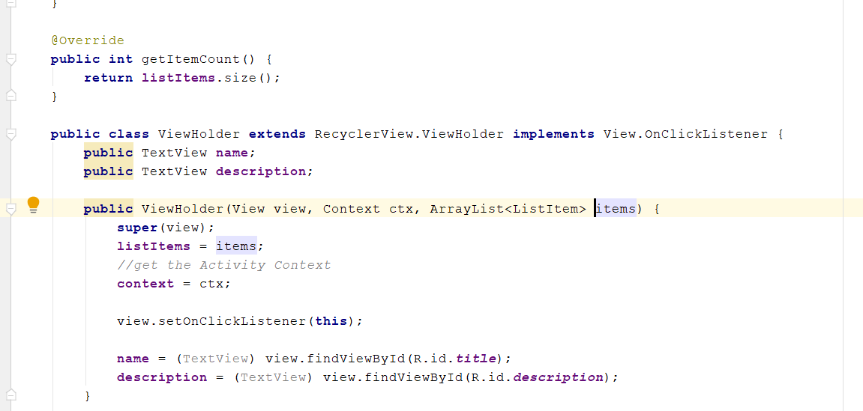**Section 3: Code based questions - 2 marks each**

Q1. In above code, what is mean by “extends”? What will happen if extends is replaced by “implements”?

*Ans. In the above code “extends” is used to inherit from the ViewHolder class within the RecyclerView. If we use “implements” instead of “extends” we might not be able to use the declared methods of the ViewHolder class without rewriting them*

Q2. In above code, why is “findViewById” preceded by “view.”?

*Ans. Because we are searching for a UI element inside the “view” that was passed to the ViewHolder class. In this case “view” might refer to a layout file that was inflated in Java class controlling the ViewHolder*